Abridged NODA Report … SPAMALOT
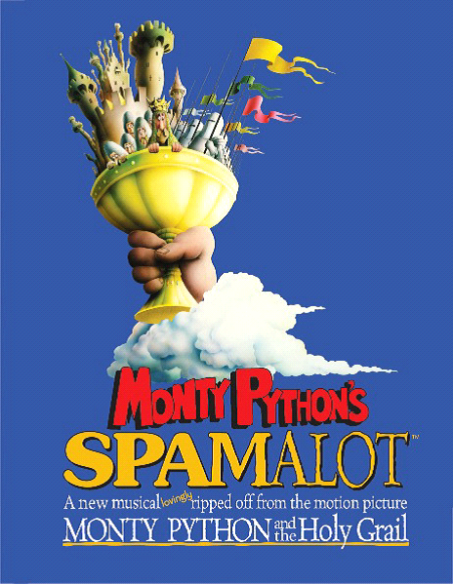
Report by Judith Watsham, Regional Rep NODA London 11 and 11A
Thank you, especially to your excellent Director Carol Vockins and Chairman Gordon Bird, for welcoming me to this production replacing your usual regional rep, Jet Maskell.
Lighting was good and the pools of light in the ‘wrong’ places were very well timed.
The back of the set was great, all credit to Graeme Vockins and the construction team for the detail. Sam Turner and the crew were slick and unobtrusive in the few changes necessitated by the need to set or remove props, which were all appropriate.
Costumes, with one exception, were excellent, which I would expect having seen your costume store, however, the Lady of the Lake’s yellow dress in the finale did not really work for me, especially as it revealed shoulder areas which had not been exposed to the sun, which contrasted with those which had! These could have been covered with make-up of course but I think that you did not use stage make up?
The ensemble was always in character and reacted well to events - singing showed the lack of an MD to control the performance although I suspect that Samantha Rawdon had drilled you all well in rehearsal and did her best as a cast member. Also, unsurprisingly, ‘Always look on the Bright Side of Life’ was the one chorus number which you all sang successfully and in unison – it is, after all, the best known one in the show.
All of you had named parts as well – some of you must have had a rush to change costumes from time to time – but you maintained your characters very well as did Camilla Fillingham as the Show Girl.
The four young dancers, Dance Captain Jessica Masseron with Troy Johnson, Katie Johnson and Joanna Fox, showed a lot of talent, all credit to Amy Lockwood your choreographer. Just one point though which probably concerns both wardrobe and Amy; the music at one point included a burst of the Can Can which always cries out for a great swishing of skirts. As space was limited perhaps skirts with frills or even a frilly petticoat under a full skirt, would have enabled you to swish in the traditional manner?
King Arthur was very well played by Michael Shepherd. An excellent characterisation and you performed ‘I’m all Alone’ with such a soulful expression on your face that it added greatly to the comedy. A good sense of timing too which showed in the interaction with ‘God’. Well done.
Patsy, Dan Walford, gave another very good performance – with a well-judged use of your expressive face. You developed such a good stoop, weighed down with your backpack, not to mention the coconut shells, that I was quite surprised to see that you were taller (when seen in the bar afterwards) than you appeared on stage.
Ethan Law leapt very athletically around the stage as Not Dead Fred and sang the number, I’m not Dead Yet very well.
Lara Savory sang and acted very well as the Lady of the Lake, as well as ‘over acting like hell’ in ‘The Song that Goes Like This’ along with Dan Chishick as Sir Galahad. You made the most of dramatising Whatever Happened to My Part? Both numbers are high points in the show and potential show stoppers. Congratulations on an excellent performance.
Sharon Young displayed excellent actions and reactions at all times, whether as Mrs Galahad, a squeaky Knight who says Ni or as an ensemble member.
Derek Lockwood as Sir Robin, came into his own with the energy of his number ‘You Won’t Succeed on Broadway’; a potentially contentious number in these very PC days and I was glad you kept it in.
The other knights, Sir Lancelot, Andy Eden, Sir Bedevere, Matthew Chishick and Sir Bors, Simon Trinder, all supported well and your entrances and exits gentlemen were always very well timed.
Rachel Lockwood as The Historian added greatly to the humour of the show, especially moving between the spotlights. Good facial expressions too although once or twice I thought you were going to lose that straight face and crack up along with the audience.
Chris Pett taunted well – in a lovely ‘cod’ French accent too - as well as performing as one of the trio of minstrels alongside MD Samantha Rawdon and Ethan Law.
Gordon Bird played several roles with great aplomb. Good sustained accents for both your main ‘bits’, Herbert’s father and Tim the Enchanter. AND I heard every word too.
Herbert, a lovely portrayal by young Jonathan Gowen, was very good. However, one odd thing struck me: was it the result of acoustics or did you use a hanging mike? When you sang at the back of the stage I heard every word, when you came to the front the tracks overpowered your voice at times
I thoroughly enjoyed your performance and thank you again for welcoming both my companion and me so very warmly.
Judith Watsham

